The Door:
The Impact on American Music

Name
Course
Instructor
Date

“The Doors” was a revolutionary American rock music band formed in 1965 in Los Angeles. The band had four members including Jim Morrison (vocalist), Ray Manzarek (keyboardist), Robby Krieger (guitarist), and John Densmore as a drummer. Jim and his colleagues went “against the grain” deconstructing the then rock culture and setting no boundaries. The quartet transformed the genre in both recording and performance moving the social and political courses. The Doors changed revolutionized the music in the 1960s and their impact is still evident in the American music.
The Doors introduced intellectual defiance into the industry ushering a dramatic change into the country’s rock music. The quartet was among the first groups of educated youths to venture into music and their knowledge to change the political and social courses. They adopted honest but controversial lyrics and radical sounds in their songs. For instance, in their single release “Light of My Life” there is a controversial line that goes “Girl, we couldn’t get much higher.” The line brought controversies and it is reported at one time they were asked to retract it by Network producers during their performance at “The Ed Sullivan Show.” However, Jim Morrison refused and performed it as it is despite it being a family-based show. The rebellion is still common in the American rock scene with educated artists taking unconventional ways to express the socio-politico issues. Contemporary bands like The Airborne Toxic Event have adopted the use of rebellious but educative lyrics in their songs.
Besides, The Doors reinvented American rock music not only through their lyrics but also instrumental. This spirit is still alive in the industry with modern bands like the Silversun Pickup, Young the Giant, and The Strokes adopting a similar approach. They use energetic drums, dynamic guitars, and orchestral chaos that reminiscence that of The Doors. Besides, their lyrics have rebellious undertones and continue to reinvent the rock music in the current century just like Morrison and colleagues in the 1960s. They did not just sing love lyrics but also included political messages to their audience. Perhaps their political messages became a political threat to the ruling class hence the arrest of Morrison after the Miami concert. He was accused of indecent exposure yet to date there is no confirmation he actually exposed his nudity or not.
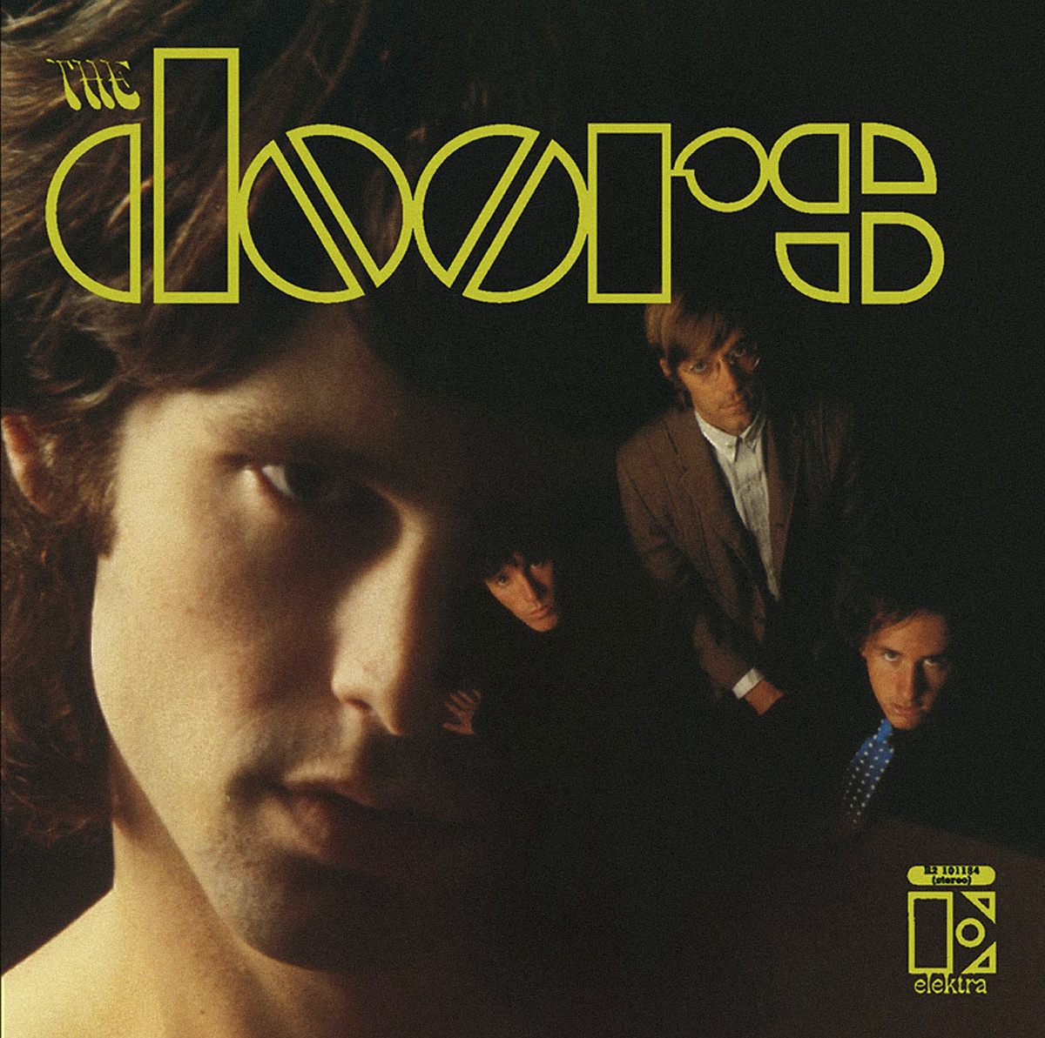
Pic 1: Cover photo for their first album
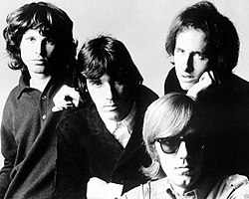
PIC 2: The Doors Band members
Also, The Door redefined rock band by incorporating intellectualism and other instruments not part of the genre. Each of the four band members had a distinct role in defining their music. For instance, Morrison was the lead singer whereas John Densmore and Robby Krieger were drummer and guitarists respectively. Currently, The Airborne Toxic band Event continues to manifest these changes by introducing instruments like violin. The band has a trained violist among other instrumentalists who play a critical role during live performances. In other words, The Door pioneered the use of other equipment other than bass guitar and drums by the rock bands. Additionally, Morrison and his colleagues adopted an honest music lyrics which broke away from the conventional bands like the Beetle. Their lyrics focused on rebellious messages which occasionally put them at loggerheads with producers. Currently, the contemporary groups like The Airborne Toxic Event are using the similar approach and playing alternatives from the basic musical training.
“The Door” also introduced a new dressing style to the rock bands which is still evident in many contemporary groups. They had unconventional clothes and ragged hair which contrasted other bands at the time. Many rock artists preferred keeping short hair with neat clothes to symbolize the respectability of the genre. On the other hand, Morrison and his colleagues blended shaggy clothes with ragged hair that made them outstanding from other bands. The dressing style was also prominent in their shows and sometimes caused an uproar among the fans. For example, Morrison removed his leather jacket during their Miami show and even threatened to expose his nudity to the fans. The incident attracted a lot of negativity leading to his arrest which adversely affected his music career and that of the band. Similarly, the American rock bands are currently using unconventional dressings and hairstyles and seem to draw a lot of inspiration from The Door. Modern rock bands are also using similar dressings and styles and there is no doubt it can only gain prominence. Essentially, The Door opened new avenues that were initially closed to many American rock artists.
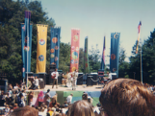
PIC 3: The Door performing at a music festival
Additionally, the influence of Morrison and his colleagues is still evident in the poetic nature of modern rock music. Contemporary rock artists (including those in other genres) have adopted poetic lyrics that convey a specific message to the audience. For instance, the wording in the song “End of the night” is incredible. The words are carefully picked and arranged to create musicality and rhythm. Besides, they contain a message that requires intellectual interpretation to make it understandable. A similar trend has gain popularity since then and currently part and parcel of the American music industry. Other music genres like hip-hop and jazz have also adopted the same trend. In essence, The Door's lyrical revolution is still evident in American music and only stand a chance to gain popularity. The poetic wording helps the artists to pass their intended message without conflicting the existing laws. In fact, the influence goes beyond American borders as it gains popularity in countries that have limited freedom of speech.
Morrison sang poetically about the challenges facing the young people in the song “The Doors of Perception” and the young people easily identified with the song. The lyrics in this song contain bitter truths that most bands at the time did not want to confront. Instead, they focused on “sweet words” and love songs that depicted a peaceful society whereas the populace was facing constant problems. Similar wording is evident in the song “The End” where he talks of an ending relationship. "This is the end/ Beautiful friend/ This is the end/ My only friend, the end/ …Can you picture what we'll be/ so limitless and free." The song symbolically depicted the end of an old generation of politicians and musicians while paving way for a new era. America underwent several political and social reformations in the sixties paving the way to the current society. Today, artists are using their talents to address the challenges facing the society and ask for redress from the relevant authorities. Presently, artists use their songs to advocate for the rights of marginalized and antiracism among other areas.
In conclusion, "The Doors" not only revolutionized the rock band in America but also other music genres. The four-member band broke away from the conventional composition and delivery of rock music. Instead, they adopted a rebellious approach in the composition and live performance. Their unconventional approach opened a new era in the American music scene as artists began to use poetic lyrics to address the issue affecting the community. Even though the band did not last long its impact on American rock music and other genres are still evident. Contemporary rock bands like The Airborne Toxic Events continue to carry on with their legacy by breaking away from the norms both in composition and performance. There is no doubt the quartet influence will remain the American music industry for long.

References
Covach, John. 2017. "The hippie aesthetic: cultural positioning and musical ambition in early progressive rock." Rock Music (Routedge) 65-7.
Crenshaw, Christopher. 2014. "Five to one: Rethinking the Doors and the sixties counterculture." Music and Politics 8, no. 1 .
Holm-Hadulla, M Rainer, and Alina Bertolino. 2014. "Creativity, alcohol and drug abuse: The pop icon Jim Morrison." Psychopathology 47, no. 3 167-173.
Michele, Biasutti. 2012. "Group music composing strategies: A case study within a rock band." British Journal of Music Education 29 no. 3 343-357.

Covach, John. 2017. "The hippie aesthetic: cultural positioning and musical ambition in early progressive rock
Michele, Biasutti. 2012. "Group music composing strategies: A case study within a rock band." British Journal of Music Education 29.3
Holm-Hadulla, M Rainer, and Alina Bertolino. 2014. "Creativity, alcohol and drug abuse: The pop icon Jim Morrison." Psychopathology 47, no. 3 167-173.
Crenshaw, Christopher. 2014. "Five to one: Rethinking the Doors and the sixties counterculture." Music and Politics 8, no. 1

